Fgsdf
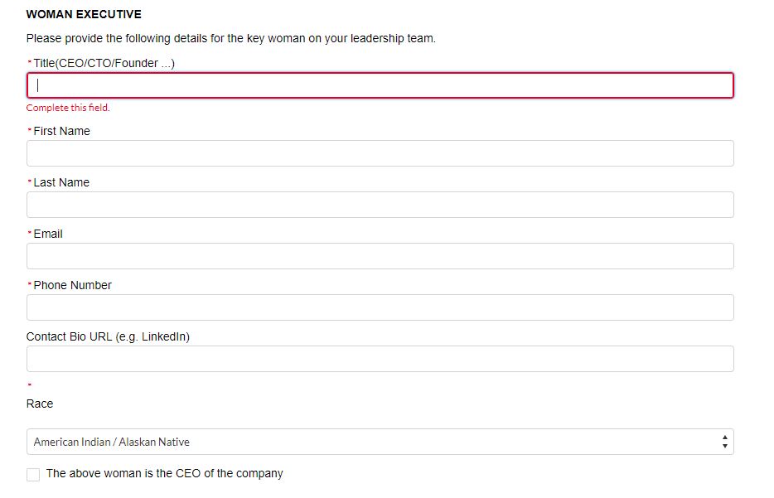

Co-founder and CEO
Elaine
esong@woundreference.com
+19258185048
https://www.linkedin.com/in/elaine-horibe-song/

Co-founder and Chief Nursing Officer
Tiffany
thamm@woundreference.com
https://www.linkedin.com/in/tiffany-hamm-bsn-rn-cws-achrn-uhmsads-a3641863/
Endereço Elaine (Moraga)

Life Sciences / Healthcare Services
Technology / Education

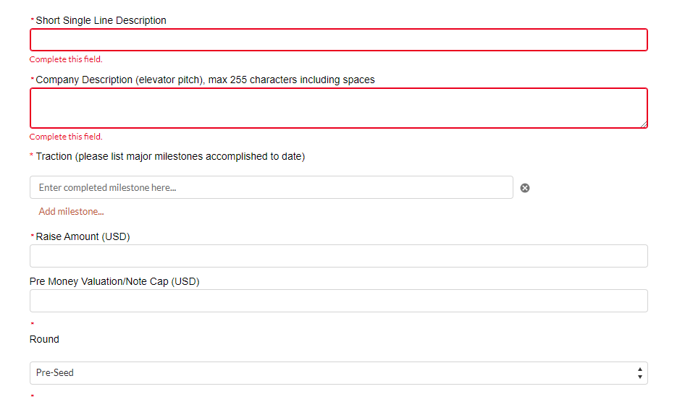
WoundReference is the first and only wound care-specific platform providing clinical, reimbursement and operations intelligence at the point-of-care

Unmatched clinical, reimbursement, and operational support, with evidence-based algorithms in wound care and hyperbaric medicine enabling clinicians to provide patient-centered care, substantially improving clinical outcomes.

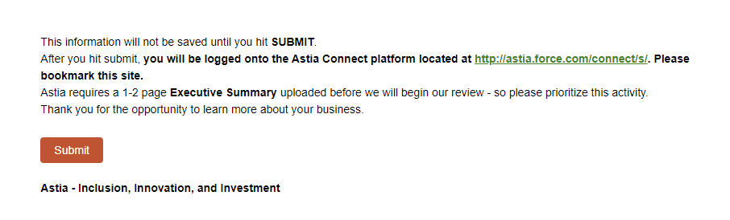

fd

